
Palmer Timeshare Claimants Group

May 2008

Dear

PALMER CLAIMANTS’ GROUP
MAY 2008 - BULLETIN

I am writing to update you on the latest developments.

The sale of Yucca Park has not yet completed but the Joint Trustees are continuing to sell the apartments individually, as buyers become available. As previously reported, all of the sale proceeds are being paid to the Spanish Authorities and the Joint Trustees still believe that all debts that were owed to the Spanish Authorities will be paid in full once all of the apartments have been sold.

The Joint Trustees are now in the process of actively marketing the resorts of Tenerife Royal Gardens and Los Olivos. Unfortunately, it appears that there are still criminal embargoes registered against the resort of Club la Paz and this issue must be resolved before this resort can be marketed. The Joint Trustees are considering how best to achieve this.

The Joint Trustees have also agreed the sale of some additional assets that belonged to Mr Palmer including a bowling alley, a restaurant and some offices. The Joint Trustees expect the sale of these assets to be completed within the next 3 months.

We will write to you again in September 2008, unless there are any important developments to report to you in the meantime.

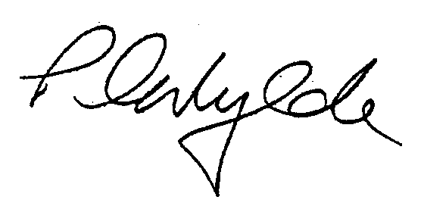
Yours sincerely

PETER WYLDE
PARTNER

